Cloud Diver:
A Variable Wing Geometry Data Sampling Platform
By Harrison Warrick
Content:
Pg 1 – Content
Pg 2- Introduction
Pg 3- The Platform
Pg 12 – The Use case
Pg 14- Similar systems

Introduction:
Modern storm forecasting relies on three main sources of data collection, ground stations, radiosondes, and Doppler radar. All are useful but have major limitations: Radiosondes are unsuitable for low level data collection and lack rapid-response capability, ground stations can only gather data from a small area, and Doppler radar is limited to remote sensing. Cloud Diver seeks to augment all three by allowing for rapid deployment of a platform that can gather data from a wide area of the lower atmosphere, as well as gather direct data from returns spotted on Doppler radar. It accomplishes this through three main capabilities. The first of which is onboard data collection of pressure, temperature, and humidity via the underslung payload, in effect a radiosonde on a fixed wing platform. The second is a high wing aspect ratio of approximately 8.4, allowing for limited soaring and use of thermals, extending flight time. The third is the center-span located hinge and internal retraction mechanism, allowing for the high-aspect wings to be folded into themselves, allowing semi-ballistic diving through high-wind environments, such as supercells and tornadoes (though that capability will remain theoretical in the absence of testing).
The Platform:
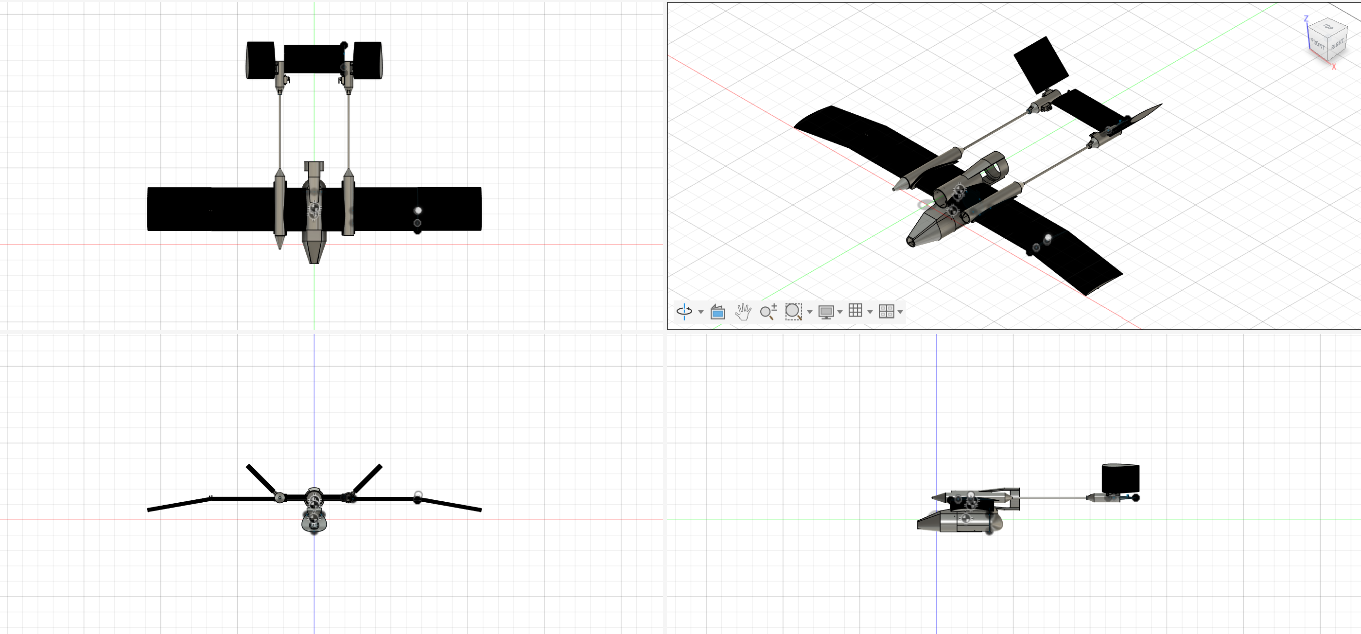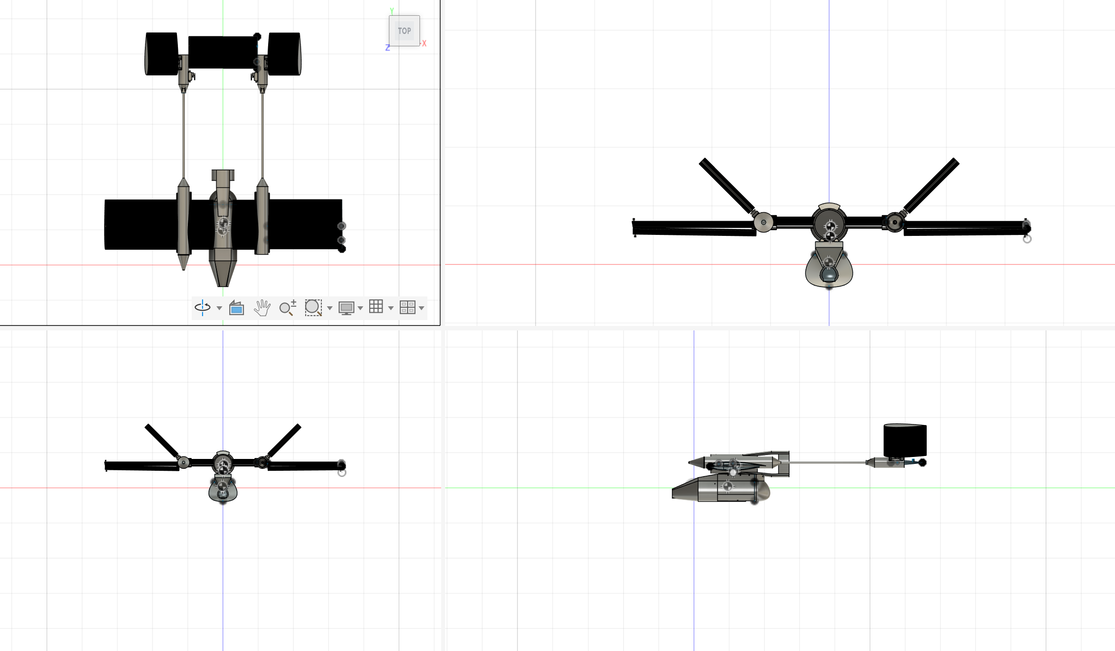
Fig. 1 and 2, revision 3 in wing extended and folded configurations respectively
The Cloud Diver platform is a 2kg, mid-wing, twin boom, pusher configuration airframe composed of three primary components, the payload, the wing systems, and the control systems. Each is built around off-the-shelf hardware and uses 3D-printed thermoplastics (for revision 3 and 4, PLA and PETG) to allow for in-the-field repairs and servicing, including full part replacement. Thrust is provided by a 50mm Electric ducted fan, which while less efficient than other options, is more resilient to debris such as hail and allows more focused inflow/outflow paths, allowing air to be drawn over the central wing and pushed over the rear control surfaces, improving low-speed lift and control authority respectively. Due to the hazardous conditions in which the drone will operate, total parts cost has been kept below $500.

Overall Specifications:
Weight: | Revision 3: 900g  Revision 4: ~2000g
Wingspan | 1086 mm
Length | 721 mm (with payload)
Stall speed:  (blown wing effect introduces some variability, stall speed is lower at high throttle and vice versa) | Revision 3: approximately 8 m/s at full throttle  Revision 4: approximately 13 m/s at full throttle
Endurance (cruise at 15-amp continuous current draw for rev 3, 20 for rev 4 and 85% efficiency): | Revision 3: 5 minutes at cruise  Revision 4: 30 minutes at cruise
Battery type | Revision 3: 1 4s 1300 mah battery  Revision 4: 2 4s 6500 mah batteries

The Payload:
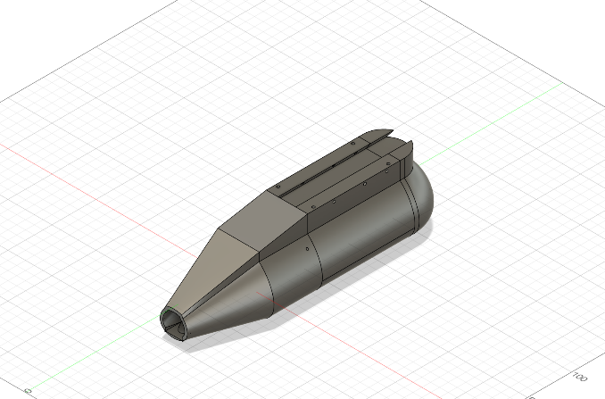

Fig.3, payload bay in isolation
The payload bay consists of three components, The nose cone, holding the mounts for the wing retraction servo and camera, the payload bay, holding the sensors and data collection Arduino, and the endcap. It attaches to the airframe via a dove-tail slot and is held in place by 3 M3x50 bolts. It likewise will hold a 4G hotspot; to allow data to be down-linked live (though with airborne coverage questionable, this may be supplemented with a radio). Temperature and humidity sensing in the prototype payload is provided by an AHT10, however future versions will use a SI7006-A20, as it offers a smaller size and faster response time, allowing for an additional module for averaging and redundancy. Pressure is measured by two BMP280 pressure modules. Temp/RH sensors are mounted on either a fixed platform or rotating door depending on configuration, allowing the shielding of the temperature sensors from sunlight. Pressure sensors are mounted inside the payload bay, in a manner similar to a pitot-static system on other aircraft. Wind measurement capability is planned but not yet designed or integrated.

The Wing System:
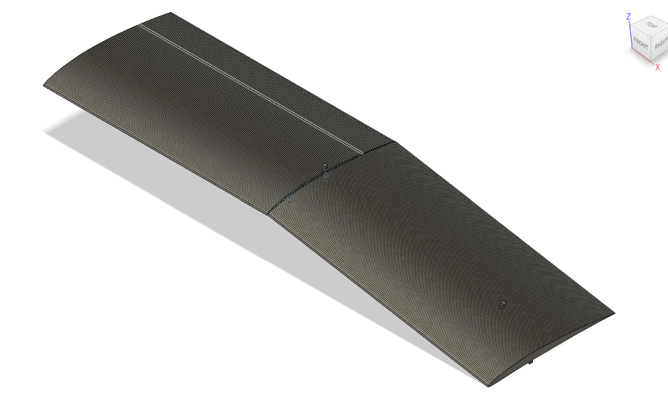

Fig. 4, the left wing extended.

The Wing System is built around two wing segments of 245mm span and 140mm chord NACA 4406 airfoil, with the outer section angled down at 10 degrees to create a limited anhedral to compensate for over-stable properties of the airframe, as the slung payload contributes to a very strong self-righting tendency (keel effect). Likewise, the slight angle reduces the force required to retract the outer section from full extension. When needed, the outer section rotates such that the lower surfaces of the wings are pressed against each other, creating an approximately symmetric section of roughly 12% thickness, dramatically reducing the lifting, and bending force exerted on the wing, especially at low angles of attack. This increases V_{ne} to the point at which the tailerons are physically torn from their mounts, most likely above 150 mph (though this cannot be confirmed in the absence of destructive testing). Maximum wing retraction speed is between 18 and 41 meters per second, depending on angle of attack, assuming the center of lift is at the exact center of the wing and ignoring the pitching moment of the airfoil. There are no ailerons on these wings, allowing for rapid replacement if needed.
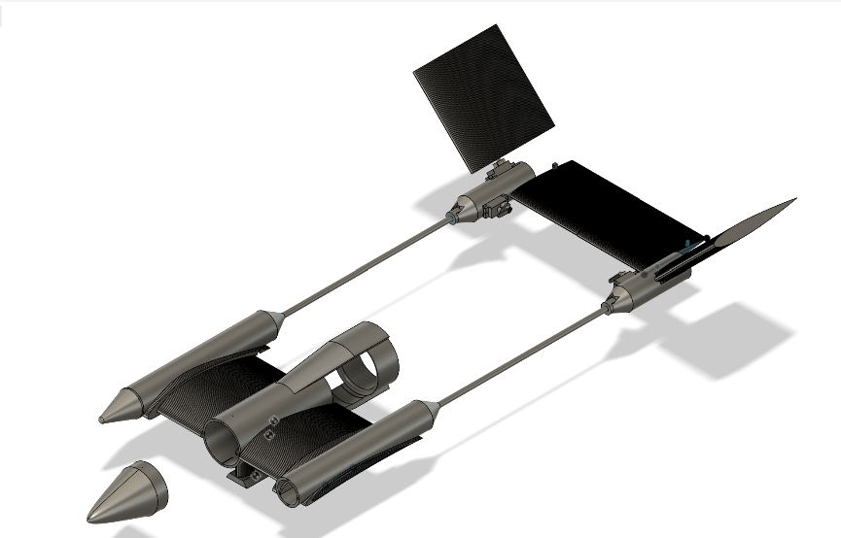
Control Systems:

Fig 5. The avionics system with center nosecone detached and left cone removed.

The control systems are composed of the avionics bay, the motor mount, the payload mount, and the empennage. As of revision three, the Avionics Bay holds the battery, ESC, and receiver, with a removable nose cone for easy access and maintenance. The motor mount attaches to the avionics bay and holds a 50mm electric ducted fan (EDF). The mount is designed to draw air over the central wing, a 200mm span by 140mm chord NACA 6412 airfoil, allowing shorter takeoff and improved lifting capacity. The exhausted air from this EDF flows over the empennage, improving control authority. The empennage consists of four surfaces, two full-moving elevators, and two full moving tailerons, each driven by a 9-gram metal gear servo.

Revision 3.1 and 3.2
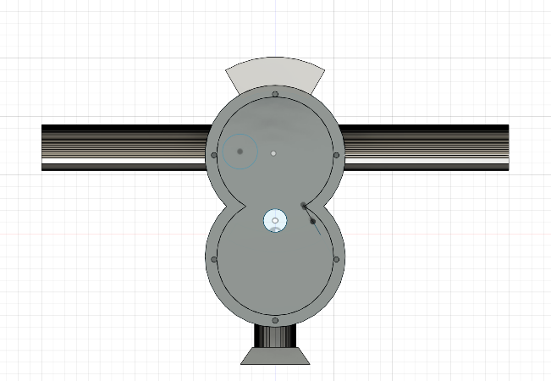

Fig. 6, the “double bubble” avionics bay
Revisions 3.1 and 3.2 are incremental improvements to the existing revision 3. 3.1 added a “Double Bubble” style avionics bay, increasing available volume for batteries and onboard electronics. 3.2 Built off of 3.1, and now incorporates a removable motor mount based around 4 M3 bolts.

Current prototype:
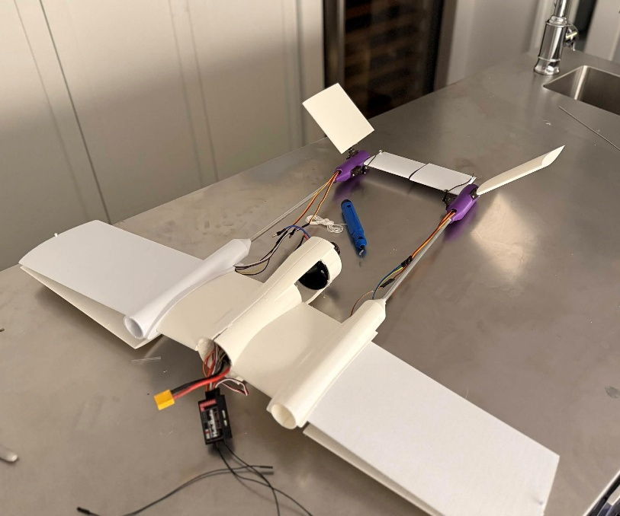

Prototype 3 during control systems testing, sans nose cones and payload, with wings folded
The current prototype, revision 3.2, is intended as a flight demonstration article, focused on evaluating the flight limitations and characteristics of Cloud Diver, as such it has some limitations and compromises. The most notable of which is the absence of the onboard flight computer and complete payload, as well as the locking of the wings at full extension. Due to limited testing space, it is imperative that take-off distance be as low as possible, necessitating the shedding of weight wherever possible, including a smaller battery, and the use of light-weight thermoplastics. However: Revision three has a fully functional control system, is flight-ready, and has had the stripped-down payload tested, though as the initial flight test article, it is expected that it will be damaged past the point of economical repair.

Future improvements:
Current plans for revision four include: a redesigned empennage to further improve control authority, an onboard flight computer and GPS for automated flight, and provisions for ground launch hardware, such as rocket assisted takeoff or catapult launch. Likewise, revision four will include a functional wing fold mechanism and payload and is planned to function as the testbed for onboard sampling procedures and software. Beyond revision four, the primary improvements are planned to be onboard wind sensing, swappable motors to allow more efficient flight, and the use of advanced thermoplastics such as Polycarbonate and carbon fiber infused materials.

The Use Case:
Cloud diver is designed to be used in two modes, data gathering mode and nowcasting mode. Each uses slightly different hardware, and a given airframe can be swapped between each mode rapidly.

Data Gathering Mode:
Data Gathering mode will use mechanical lockouts to hold the wings at extension and will use a lighter payload and larger battery to allow for wide area sampling of atmospheric conditions. As such, it will primarily use automated flight systems to track over a given area before returning to the launch site to be landed by an operator. The intended use is for gathering observations for short and medium range Forecasting, similar to radiosondes. Past revision four, it is planned that the EDF will be swapped for smaller, more efficient propellers in this mode.

Nowcasting Mode:
Nowcasting mode will have the wings unlocked, and use a payload bay with retractable sensors, as well as an assisted launch to rapidly gain altitude. From there, an operator on the ground will fly the aircraft towards the intended target, before executing the dive procedure, as follows:
- Set throttle to full
- Pitch up sharply (aiming for approximately 45 degrees) to create momentary stall, allowing for easier retraction of the wing.
- Activate the wing fold servo.
- Begin to roll the aircraft inverted.
- Deploy sensors and activate data logging.
- Set throttle to zero.
- Point the nose of the aircraft at the ground, ideally passing through the center of the storm.
- At a set altitude, begin to pitch out of the dive.
- Once clear of the storm, or as necessary, deactivate the wing servo and return to flight.
10) Depending on battery level, either return to base or begin climbing for another dive.

The aircraft rolls inverted to improve survivability in the event of loss of signal, as the slight upward pitching tendency of the aircraft will cause it to slowly return to level, and thus exit the storm having executed a 180 in heading, pointing it back towards the launch site.

Regulations:
As it stands, the largest obstacle to Cloud Diver is FAA regulations around beyond visual line of sight operations (BVLOS). Under the current part 107 regulations, a waiver would be required should the aircraft have to operate above four hundred feet from the ground, with less than 3-mile visibility, or within 2000 feet of clouds. Likewise, part 107.200 requires individual waivers for BVLOS operations, which is impractical for both data gathering and nowcasting modes. Under the proposed part 108, data gathering becomes well within reason to operate on a wide basis, but the nowcasting mode still needs individual waivers.

Similar Systems:
Model | Cloud Diver v4 | S0 | Aerosonde
Cost | ~$500 | Not Public | N/a (rental)
Launch Mechanism | Hand, Ground system | VTOL | Vehicle
Endurance | ~30 minutes | ~90 minutes | >24 hours
Sensors | T, RH, P | T, RH, P, wind | T, RH, P wind
Mass | 4.4 lbs | 3.5 lbs | 29 lbs
Use case | Nowcasting, area data collection | Area data collection | Area data collection

Per https://bst.aero/black-swift-s0-vtol-uas/
Per https://www.textronsystems.com/products/aerosonde-uas

